30 OCTOBER 2018
MELVILLE LITTLE ATHLETES TO RECEIVE GRANT FOR NEW SPORTS EQUIPMENT
Melville Little Athletics Centre has received grant of over $3300 to buy brand new sports gear thanks to funds raised by Coles from selected Community Bags.
The Little Athletics centre in Melville is one of around 100 centres across Australia to receive a sports grant to replace or expand its sports equipment.
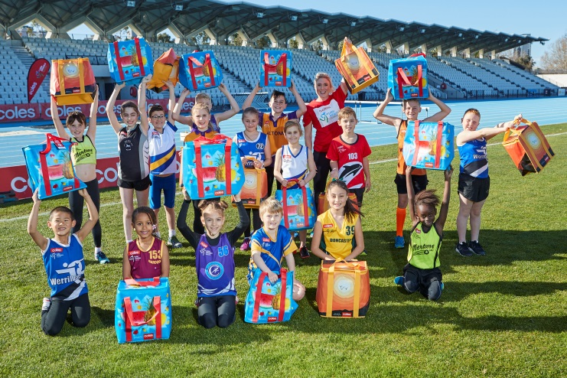
Funds for the grants are raised through the sale of specially-marked chiller bags designed by Aussie kids. For every bag sold, 25 cents is directed to the Coles Little Athletics Community Fund to provide sport equipment grants.
Coles State General Manager Pat Zanetti said Coles was delighted to provide grants to help the Little Athletics centres in locations such as Melville.
“Thanks to our customers who have bought our range of chiller bags at Coles stores, we are able to provide around $360,000 in grants for Little Athletics centres around Australia to help them purchase equipment to support activities such as High Jump, Discus, Hurdles and the various running events.
“Melville Little Athletics Centre told us they would like to receive a grant to buy shot puts, hurdles and high jump equipment and we were delighted to help because we know these are an essential part of Little Athletics to support young budding athletes,” he said.
Coles Little Athletics Australia CEO Martin Stillman said the grants were important for many centres which needed new equipment to continually provide a high quality and safe weekly experience.
“The response to the establishment of the Coles Little Athletics Fund has been fantastic, with applications flooding in from centres across Australia for the first round of funding. It shows that there’s a real demand for new sports equipment in the local community,” he said.
In addition to the chiller bags, Coles sells Community Bags which help to raise funds for SecondBite, Guide Dogs Australia and Clean Up Australia. Since June, these bags have raised enough funds to provide more than 800,000 meals through SecondBite, 100,000 pairs of kids gloves for Clean Up Australia, support to raise a litter of five Guide Dogs puppies as well as around 100 Little Athletics sports grants.
All Community Bags were designed by school children as part of a bag design competition. Coles will also sell a range of Christmas bags to raise funds for Autism Spectrum Australia (Aspect) schools.-ends-

For further information, please contact
Coles Media Line (03) 9829 5250 or media.relations@coles.com.au

